
RAMAIAH
Institute of Technology
USN | 1 | M | S

(Autonomous Institute, Affiliated to VTU)
(Approved by AICTE, New Delhi & Govt. of Karnataka) Accredited by NBA & NAAC with ‘A’ Grade

MAKEUP EXAMINATIONS – JUNE/JULY 2018

Course & Branch | : | B.E. : Common to all branches | Semester | : | II
Subject | : | Engineering Mathematics - II | Max. Marks | : | 100
Subject Code | : | MAT201 | Duration | : | 3 Hrs
Instructions to the Candidates:
- Answer one full question from each unit.

 |  | UNIT- I
1. | a) | Write the derivative of arc length of a curve in Cartesian and parametric forms. | CO1 | (02)
 | b) | Expand 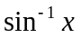 in powers of ‘x’ upto third degree terms. | CO1 | (04)
 | c) | Find the minimum value of 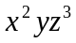subject to 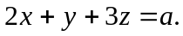 | CO1 | (07)
 | d) | Find the radius of curvature at any point on the curve | CO1 | (07)
2. | a) | Define Maxima and Minima for a function of two variables. | CO1 | (02)
 | b) | Evaluate 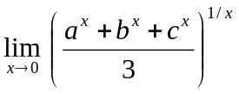 | CO1 | (04)
 | c) | Expand upto second degree terms. | CO1 | (07)
 | d) | The temperature T at any point 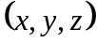 in space is given by 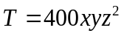. Find the highest temperature on the surface of the unit sphere 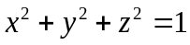. | CO1 | (07)
 |  | UNIT- II
3. | a) | Write integrating factor for the equation:  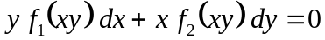 | CO2 | (02)
 | b) | Show that the family of parabolas 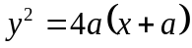 is self orthogonal. | CO2 | (04)
 | c) | Solve 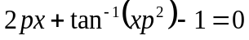 which is solvable for . | CO2 | (07)
 | d) | The temperature of a cup of coffee is 92⁰ C, when freshly poured the room temperature being 24⁰ C. In one minute it was cooled to 80⁰ C. How long a period must elapse, before the temperature of the cup becomes 65⁰ C? | CO2 | (07)
4. | a) | Write Clairaut’s Equation and also give its solution. | CO2 | (02)
 | b) | Solve 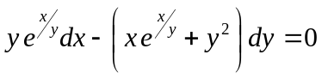. | CO2 | (04)
 | c) | Solve | CO2 | (07)
 | d) | Uranium disintegrates at a rate proportional to the amount present at any instant. If 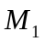 and grams of uranium are present at times and respectively, then show that the half life of uranium is 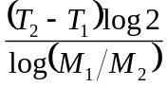 . | CO2 | (07)
 |  | UNIT- III
5. | a) | Find the particular Integral of the differential equation 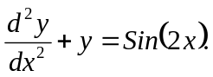 | CO3 | (02)
 | b) | Solve | CO3 | (04)
 | c) | Solve 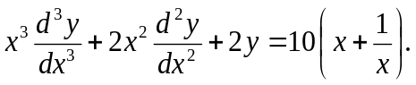 | CO3 | (07)
 | d) | The differential equation of a simple pendulum is 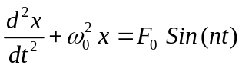, where 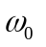 and 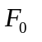are constants. If initially 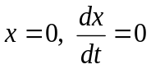, determine the motion when 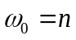. | CO3 | (07)
6. | a) | Find the particular integral of the differential equation 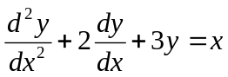. | CO3 | (02)
 | b) | Solve 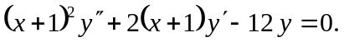 | CO3 | (04)
 | c) | Solve 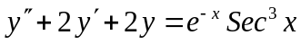 by the method of variation of parameters. | CO3 | (07)
 | d) | A condenser of capacity C discharged through an inductance L and resistance R in series and the charge q at time t satisfies the equation 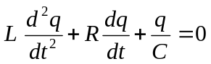, given that L = 0.25henries, R = 250 ohms, C = 2×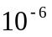 farads, and that when t = 0, charge q is 0.002 coulombs and the current 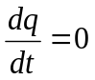. Obtain the value of q in terms of t. | CO3 | (07)
 |  | UNIT- IV
7. | a) | Define Beta and Gamma Functions. | CO4 | (02)
 | b) | If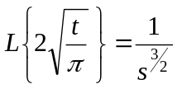 , then show that 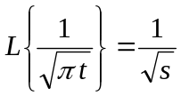. | CO4 | (04)
 | c) | Express the function 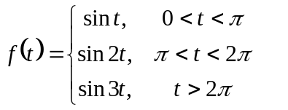in terms of the Heaviside function and hence find its Laplace transform. | CO4 | (07)
 | d) | If 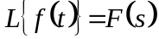,then prove that 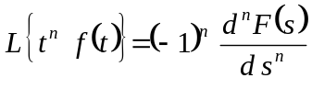 and hence find 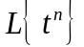. | CO4 | (07)
8. | a) | Define the Dirac-Delta function and sketch its graph. | CO4 | (02)
 | b) | Prove that:  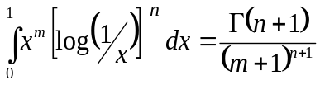. | CO4 | (04)
 | c) | Evaluate i) 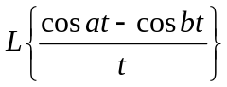 and ii) 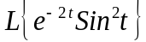. | CO4 | (07)
 | d) | Define unit step function. If , then prove that 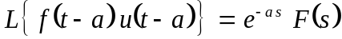. | CO4 | (07)
 |  | UNIT- V
9. | a) | Draw the graph of square wave function:  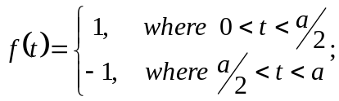 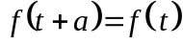. | CO5 | (02)
 | b) | Find the inverse Laplace transform of 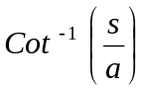. | CO5 | (04)
 | c) | Solve 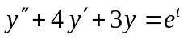 given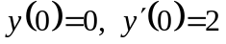 using Laplace transform method. | CO5 | (07)
 | d) | Verify convolution theorem for the pair of functions 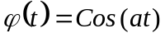and 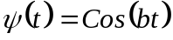. | CO5 | (07)
10. | a) | Show that convolution of two functions is commutative. | CO5 | (02)
 | b) | Find the inverse Laplace transform of:  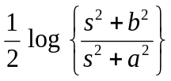 | CO5 | (04)
 | c) | If 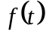 is a periodic function with period , then show that 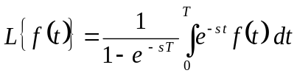. | CO5 | (07)
 | d) | Using Laplace transform method, solve the following simultaneous equations 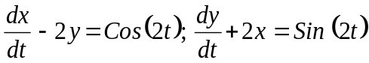given 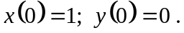 | CO5 | (07)

****************

